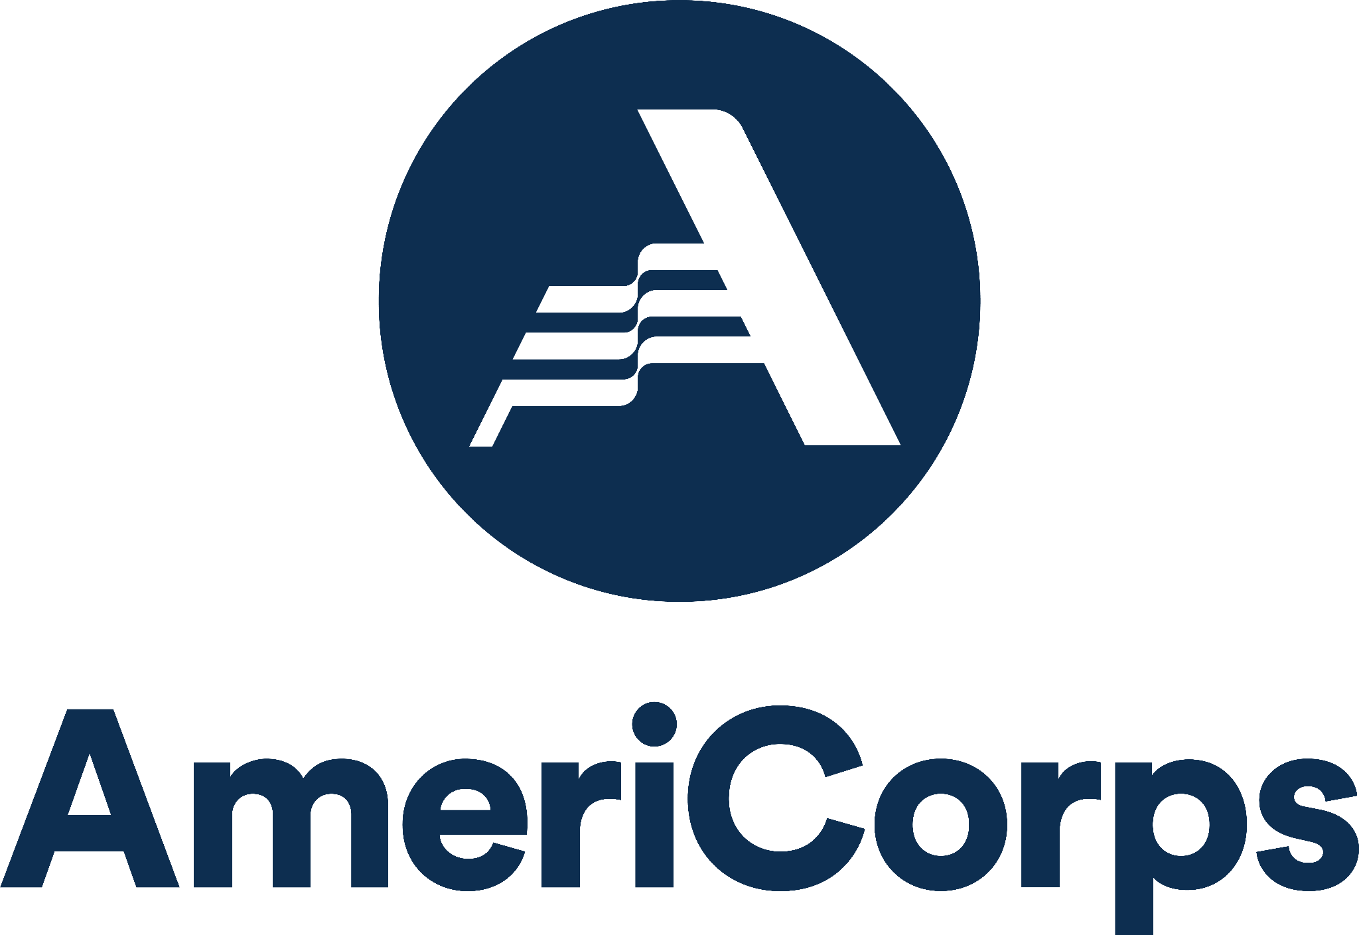

Campus Compact of Oregon VISTA: Member Growth and Development Plan

INSTRUCTIONS: After thoughtful consideration of what you hope to achieve this year, please complete this form and review it with your site supervisor. Keep a copy for yourself and submit a signed form to Campus Compact of Oregon: see your specific program calendar for due date.

This form will be referenced when member development requests are made and should be considered a working document to be revisited throughout the year. If any significant changes are made, please submit a new form to Campus Compact.

Member Name:

Placement Site:

- Describe at least two service-related goals (not limited to project-related goals) you would like to achieve during your AmeriCorps term of service.

- Describe at least two personal goals you would like to achieve during your AmeriCorps term of service.

- Describe at least two professional goals that you would like to accomplish within your own personal timeline/journey.

- Describe what you hope to accomplish through reflection during the AmeriCorps term of service.

- Describe at least two strategies that will enable you to accomplish the reflection goals listed above.

- What knowledge do you bring? How do you reground and re/member your skills and gifts in your work?

- What does wellness and your wellbeing mean to you? What does being in relationship with your well-being mean to you? What do you need this year to prioritize care for yourself?

Based upon the goals and interests identified above, the AmeriCorps member will pursue the above-mentioned, individualized educational, professional, and service-related development activities during the AmeriCorps term of service.

Member Signature: Date:

Site Supervisor Signature: Date:

