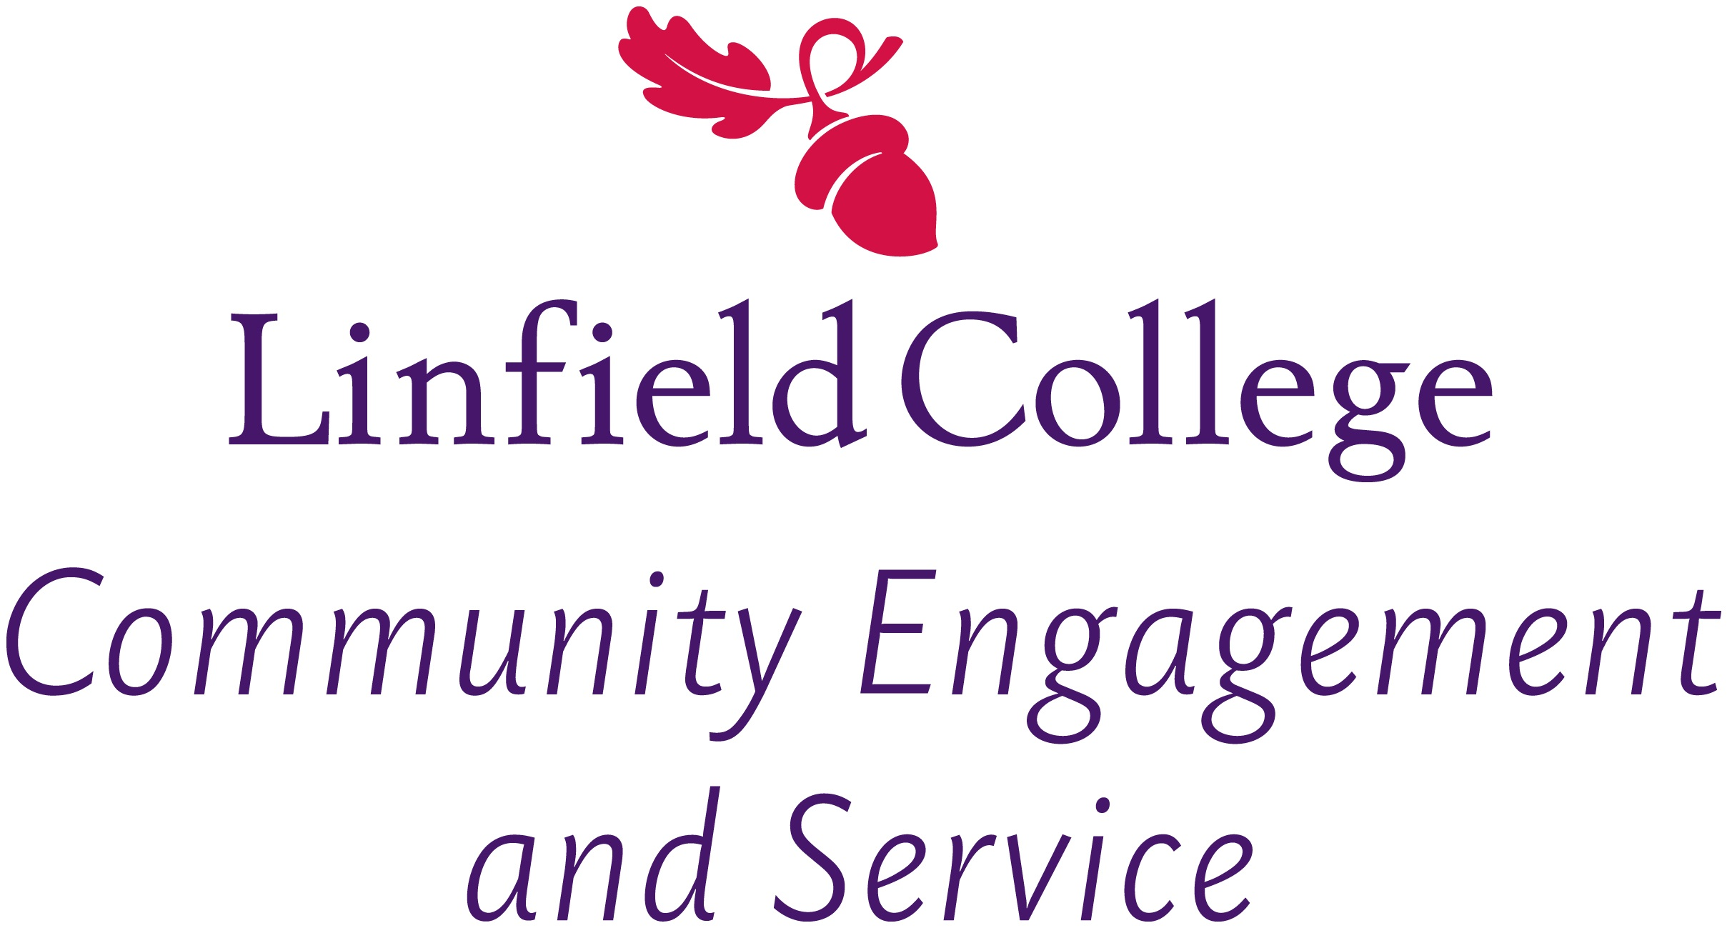


Lodging Survey
Thank you for participating in an Alternative Spring Break program hosted by the Office of Community Engagement and Service at Linfield College and for taking the time to complete this survey. The purpose of this survey is to gather information from where our programs stayed throughout the duration of their ASB program. Please return this survey to your student project leader or mail it to our office.

Your name:_________________________________________________________________________
Organization/Business:________________________________________________________________
Address: ___________________________________________________________________________
Phone Number: _________________________ E-mail address: _______________________________

1. Prior to this experience, has your organization/business participated in a Linfield College ASB program?
Yes No Unsure

2. How would you rate the communication you had with the Office of Community Engagement and Service (i.e. student leader) leading up to their stay?
Excellent Very Good Good Average Poor N/A

3. Please answer the following questions as accurately as possible.

 | Strongly Agree Agree Disagree Strongly Disagree N/A
Participants were respectful of building. | [ ] [ ] [ ] [ ] [ ]
Participants were respectful of others staying at organization/ business. | [ ] [ ] [ ] [ ] [ ]
Participants cleaned-up after themselves. | [ ] [ ] [ ] [ ] [ ]
Leaders communicated well with organization/ business staff. | [ ] [ ] [ ] [ ] [ ]
Participants did what was asked of them for general rules/expectations of people staying with your organization/business. | [ ] [ ] [ ] [ ] [ ]

4. Overall, how would you rate your experience with Linfield College ASB Programs?
Excellent Very Good Good Average Poor N/A
5. What was the most challenging aspect, if any, of this partnership?
_____________________________________________________________________________________
_____________________________________________________________________________________
_____________________________________________________________________________________

6. How did this partnership benefit your organization or business?
_____________________________________________________________________________________
_____________________________________________________________________________________
_____________________________________________________________________________________

7. What additional support could the Office of Community Engagement and Service offer to help improve or strengthen future partnerships?
_____________________________________________________________________________________
_____________________________________________________________________________________
_____________________________________________________________________________________

8. How likely are you to participate in another ASB program with Linfield College in the future?
Very Likely Likely Somewhat Likely Not Likely

9. How likely are you to recommend a partnership with Linfield College to another organization or business?
Very Likely Likely Somewhat Likely Not Likely

10. Please feel free to comment on any other aspects of this experience you would like to share:
_____________________________________________________________________________________
_____________________________________________________________________________________
_____________________________________________________________________________________
_____________________________________________________________________________________
_____________________________________________________________________________________
_____________________________________________________________________________________
_____________________________________________________________________________________
_____________________________________________________________________________________
_____________________________________________________________________________________
_____________________________________________________________________________________
_____________________________________________________________________________________
_____________________________________________________________________________________
_____________________________________________________________________________________
_____________________________________________________________________________________
_____________________________________________________________________________________
_____________________________________________________________________________________
_____________________________________________________________________________________
_____________________________________________________________________________________
_____________________________________________________________________________________

Community Engagement and Service | 900 SE Baker St. #A536 | McMinnville, OR 97128
Monique Ellefson | mellefso@linfield.edu | t (503) 883-2326

