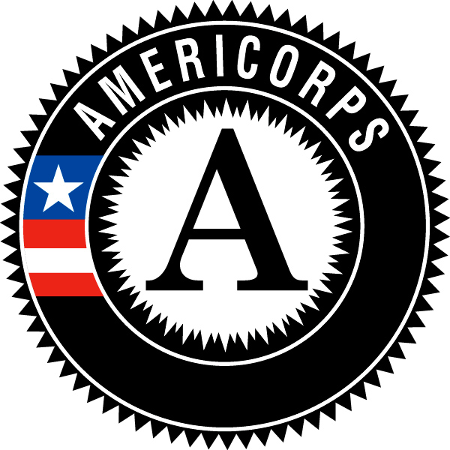

Campus Compact of Oregon
AmeriCorps Member Position Description

Position Title: College Access Corps Coordinator
Host Site Name: Lents Elementary School
Location: 5105 SE 97th Ave, Portland, OR 97266
Hours of Service: 9am-5pm M-F with some evening and weekend hours (At least 1,700 hours over the 10.5 month term of service)
Position Duration: October 2019-August 2020

Responsibilities and Related Tasks:
- Develop and implement interventions to decrease chronic absenteeism rates of students
- Carry caseload of chronically absent students
- Develop, support and facilitate programming and activities which connect school attendance and engagement with future educational success
- Serve as member of school's Student Attendance Response Team (SART)
- Accompany school staff in home visits as needed to engage with families around school attendance
- Promote values of equity and empowerment in building relationships with school community in collaboration with teachers, families, school staff and partner organizations
- Plan and carry out school-based attendance systems (check and connect, attendance group, classroom competitions, etc. as guided by SART team)
- Receive supervision from school-based staff member (counselor or admin) with weekly check-ins and on-site support
- Receive training in accessing data, attendance systems, student and family engagement from district attendance support staff
- Recruit volunteers for National Days of Service and other community service events
- Provide age appropriate college access interventions to participating youth as part of programming
- Compile and update college access program sustainability manual (one for each campus program)
- Collect and document program assessment data in required tracking tools and progress reports
- Participate in College Access Corps trainings, including orientation, mid-year training, graduation, regional cohort meetings and others as scheduled
- Engage in personal reflection
- Collaborate with other CAC teammates and national service members in your community on common projects
- Record and track hours in monthly timesheets
- Read Critical Mentoring: A Practical Guide by Torie Weiston-Serdan (provided by host site)
REQUIRED QUALIFICATIONS:
- Be a citizen, national, or lawful permanent resident alien of the United States
- Be 18 or older
- Have an AA/BA or some college
- Agree to a National Service Criminal History Check and not have a sexual offense or murder conviction (other offenses may also prohibit participation, but will be determined on a case by case basis)
- Commit to serving 1700 hours (no more than 20% of aggregate time can be spent on training/professional development and no more than 10% on fundraising)
- Ability to work well with people of diverse backgrounds
- Strong organization, problem-solving and written and oral communication skills
- Basic office computer skills, including word processing
- Program management (marketing, event planning, training, volunteer management) experience
- Strong initiative, self-starter, and enthusiasm for helping others succeed
- Committed to promoting educational equity, belonging and inclusivity
- Able to pass a criminal background check
AmeriCorps Member Benefits:
- A living allowance of $14,000 for the term of service, dispersed monthly
- An education award of $6,095 (upon successful completion of service)
- Health benefits
- Loan forbearance and interest accrual payment on qualified student loans
- Child care (if eligible)
- Training and professional development opportunities
- Access to an extensive network of AmeriCorps Alums
- Members will be given a mid-year and end of year member evaluation from their program supervisor

