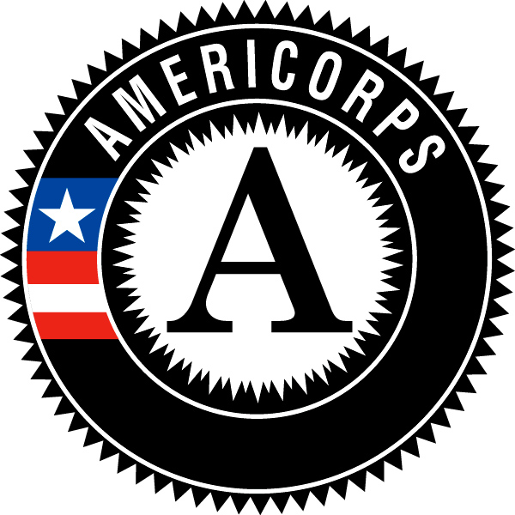

Campus Compact of Oregon
AmeriCorps Member Position Description

Position Title: College Access Corps Coordinator
Host Site Name: Kelly Elementary School
Location: 9030 SE Cooper St, Portland, OR 97266
Hours of Service: 9am-5pm M-F with some evening and weekend hours (At least 1,700 hours over the 10.5 month term of service)
Position Duration: August 2019-June 2020
Responsibilities and Related Tasks:
- Develop and implement programming to support academic engagement of students
- Carry caseload of chronically absent students
- Develop, support and facilitate programming and activities which connect school attendance and engagement with future educational success college/career opportunities and post-secondary pathways
- Serve as member of school's Student Attendance Response Team (SART)
- Promote values of equity and empowerment in building relationships between SART and students
- Plan and carry out school-based attendance systems (check and connect, attendance group, classroom competitions, etc. as guided by SART team)
- Build relationships with students, families, school staff, and partner organizations to promote student engagement, academic success and post-secondary pathway
- Receive supervision from school-based staff member (counselor or admin) with weekly check- ins and on-site support
- Receive training in accessing data, attendance systems, student and family engagement from district attendance support staff
- Recruit volunteers for National Days of Service and other community service events
- Provide age appropriate college access interventions to participating youth as part of programming
- Compile and update college access program sustainability manual (one for each campus program)
- Collect and document program assessment data in required tracking tools and progress reports
- Engage in personal reflection
- Collaborate with other CAC teammates and national service members in your community on common projects
Campus Compact of Oregon AmeriCorps Member Responsibilities:
- Attend all Campus Compact of Oregon required trainings and events
- Complete and submit all Campus Compact of Oregon required progress reports, timesheets, and other paperwork
- Read Critical Mentoring: A Practical Guide by Torie Weiston-Serdan
Required Qualifications:
- 21 years and older
- AA, BA/S or some college
- Demonstrate a commitment to or willingness to explore issues of racial justice and equity
- A U.S. citizen, U.S. national, or lawful permanent resident
- Commit to serving 1700 hours (no more than 20% of aggregate time can be spent on
- training professional development and no more than 10% on fundraising)
- Ability to work well with people of diverse backgrounds
- Strong organization, problem-solving and written and oral communication skills
- Basic office computer skills, including word processing
- Program management (marketing, event planning, training, volunteer management) experience
- Strong initiative, self-starter, and enthusiasm for helping others succeed
- Committed to promoting educational equity, belonging and inclusivity
- Able to pass a criminal background check
AmeriCorps Member Benefits:
- A living allowance of $14,000 for the term of service, dispersed monthly
- An education award of $6,095 (upon successful completion of service)
- Health benefits
- Loan forbearance and interest accrual payment on qualified student loans
- Child care (if eligible)
- Training and professional development opportunities
- Access to an extensive network of AmeriCorps Alums
- Members will be given a mid-year and end of year member evaluation from their program supervisor

