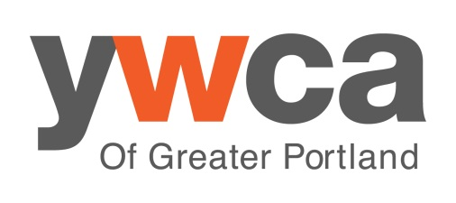
ongoing learning

List compiled by YWCA of Greater Portland Social Change Program and Basic Rights Oregon

Five things you can do for racial justice in Oregon

- Invest in learning. If you don’t identify as a person of color, educate yourself on the varying histories and politics of communities of color. Examine political and interpersonal situations through the lens of interpersonal, cultural and institutional racism.
- Create space and practices to hold people accountable. Get comfortable letting those around you know when they’ve stepped over a line, and be receptive when others hold you accountable too. Prioritize impact over intention.
- Be conscientious about the language you choose. While there are similarities between racism, homophobia, sexism etc, it’s important to remember that there are differences too.
- Educate yourself and others on ballot measures and other issues.
- Get involved with organizations working for racial justice. See list on reverse.

YWCA’s Social Change Program

customized workshops
We provide customized curriculum for your group, on matters of oppression, race, gender, LGBTQ issues, domestic violence and other social justice subject matter. For a full description, see our website at http://ywcapdx.org/what-we-do/training-for-social-change or contact Choya Adkison-Stevens at training@ywcapdx.org, 503-294-7480

advocacy training
We offer one to two three-hour classes each week. Find our course list online at https://ywcapdx.org/fresh-yw/upcoming-events/

recommended reading
Witnessing Whiteness: The Need to Talk About Race and How to Do It by Shelly Tochluk
Damali Ayo’s innovative and practical advice, www.fixracism.com
Colorlines blog, http://colorlines.com/
Understanding Prejudice website, http://www.understandingprejudice.org/
Men Can Stop Rape, http://www.mencanstoprape.org/

recommended films
Local Color – Oregon’s race history, available on pbs.org

Race Talks

A monthly presentation on race related issues, followed by small group discussion. Second Tuesday of every month, 7-9pm, McMenamin’s Kennedy School Gym, free

Uniting to Understand Racism

Six-week interracial dialogues; you can join a dialogue series, or bring the program to your work, church or other group. For more information, visit www.understandracism.org

Causa

Oregon’s statewide grassroots immigrant rights coalition. www.causaoregon.org

PCUN

Organizes farmworkers, nursery and reforestation workers, and is Oregon’s largest Latino organization. www.pcun.org

Oregon Action

Takes pride in developing outstanding leaders from communities who are traditionally on the downside of power – people who are low income, women, people of color, immigrants, and those with felony backgrounds – building their skills and ability to strengthen their communities. www.oregonaction.org

Western States Center

Mission is to build a progressive movement for social, economic, racial and environmental justice in the eight Western states of Oregon, Washington, Idaho, Montana, Wyoming, Nevada, Utah and Alaska. www.westernstatescenter.org

Center for Intercultural Organizing

A diverse, grassroots organization working to build a multi-racial, multicultural movement for immigrant and refugee rights. www.interculturalorganizing.org

Partnership for Safety and Justice

Formerly the Western Prison Project, unites people convicted of crime, survivors of crime, and the families of both to redirect policies away from an over-reliance on incarceration to effective strategies that reduce violence and increase safety. www.safetyandjustice.org

