Dear

I hope this letter finds you well! I’m writing to tell you about my plans for spring break this year. As you may know, I am currently studying nursing at Concordia University. From March 21st-28th, I have been selected to travel with 15 other students and 2 staff advisors to participate in an alternative spring break program in New Orleans, LA.
On this trip, our team will be partnering with Habitat for Humanity to rebuild homes for families throughout the area who were affected by Hurricanes Katrina, Gustav, and Isaac. Since Katrina struck the area in 2005, New Orleans area Habitat for Humanity has built or restored over 557 homes with over 285,000 volunteers. Concordia University has partnered with Habitat for over 5 years and I am excited to become a part of this legacy! I will be learning about poverty, housing insecurity, community development, and the issues that affect communities along the Gulf Coast in regards to natural disaster preparation.
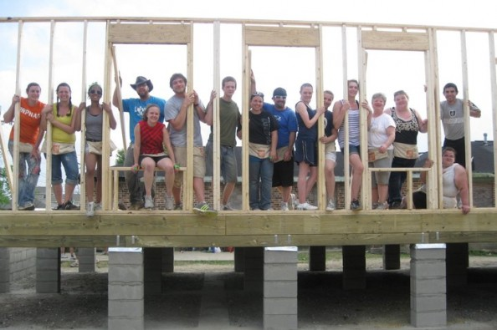
Leading up to our trip, we will be learning about the social issues mentioned above through books, discussions, movies, pre-builds with Habitat for Humanity, and written reflection. There will also be nightly reflection activities on the trip and a chance to bring back what we learned to the Portland community through local service projects with the Portland chapter of Habitat for Humanity.
I am so excited to have the chance to go on this trip because I am committed to serving my community and hope to make a difference in the lives of those living in New Orleans and in Portland. By going on this trip, I will be strengthening my lifetime commitment to serve while helping dozens of people impacted by poverty.
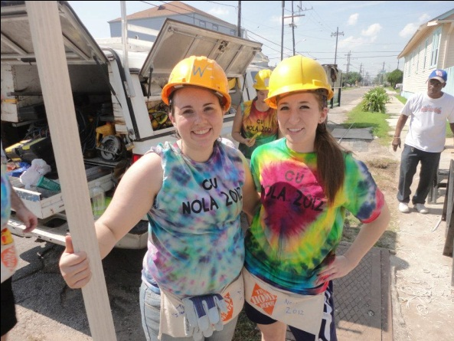
Make a Difference
However, in order to go on this trip I am responsible for paying $850 to cover my transportation to and from New Orleans, food, housing, and the cost of supplies for the projects. I will be participating in several fundraisers to help cover my costs but I know additional money will be needed. I hope you will consider making a financial contribution to help me participate in this trip. Any amount of money would be much appreciated! My goal is to find 30 people willing to partner with me on this endeavor by donating $25 to help me make a difference in the lives of the hurricane-ridden community of New Orleans, LA.

Please take a moment to consider how your partnership will not only be supporting me, but will be a personal investment into helping hundreds of people in both New Orleans as well as in Portland.
Thank you so much for taking the time to read this letter. It is through the love and support of family and friends that I feel committed and able to serve others. If you have any questions please don’t hesitate to let me know; I can also put you in contact with the staff in charge of the program to answer any logistical questions you might have.
If you would like to financially support my trip with a tax-deductible donation, all checks can be made out to “Concordia University Alternative Break Program – New Orleans” and should be mailed back using the enclosed envelope.
Thank you so much,

