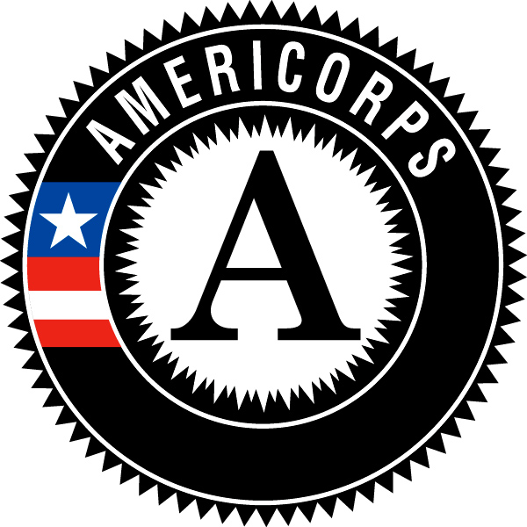

Campus Compact of Oregon
Connect2Complete AmeriCorps Member Position Description

Position Title: Equitable Pathways Specialist: Get on the Path
Host Site: Clackamas Community College
Location: Oregon City, OR
Hours of Service: 9am-5pm M-F with some evening and weekend hours (At least 1,700 hours over the 10.5 month term of service)
Position Duration: August 2019-June 2020
Years of Project: 1st year
Summary of Position: The AmeriCorps Member will serve at Clackamas Community College for the 2019-20 academic year within the Enrollment Services team. Many CCC students are first-generation and/or non-traditional and may have limited knowledge of how to navigate the college systems, tools, and services, most of which are required in order to successfully enroll and complete the first term. The member in this role will support CCC’s Guided Pathways efforts of helping students “get on a path” by engaging newly admitted, first generation and non-traditional applicants with navigating the systems, policies, and steps necessary to be ready for registering and enrolling in coursework for the identified application term. This includes assisting students with establishing a focused educational plan, creating a clear financial plan, meeting with staff from advising and career services, getting registered and using classroom tools like the library, syllabus, and Moodle.
Responsibilities and Related Tasks:

- Proactively and avidly follow up with identified students via phone, email, and in person meetings to provide information about getting started steps including filing the FAFSA, completing the required online orientation module, meeting with the placement and advising offices, identifying an educational focus area, and establishing a financial plan
- Facilitate conversations with applicants and their families about required next steps to establish an educational, career, and financial plan
- Create at least 2 service opportunities for students and volunteers
- Develop and implement in person and webcast tutorials that assist students with learning how to use key tools and systems including accessing the MyClackamas Portal, library tools, and the online learning platform Moodle
- Develop written and print instructional materials that assist students with learning how to use key tools and systems including accessing the MyClackamas Portal, Navigate, and Moodle
- Connect students to college and community services as appropriate
- Participate in college trainings, staff meetings, and related professional activities as appropriate
- Serve as a resource for students from diverse and underserved backgrounds to actively identify and advocate for the removal of institutional barriers that impact academic and professional success
- Communicate issues and/or barriers to completing required steps to CCC leadership and assist with addressing identified barriers as appropriate
- Engage in assessment activities of related programs as appropriate
- Engage in personal reflection
Campus Compact of Oregon AmeriCorps Member Responsibilities:
- Attend all Campus Compact of Oregon required trainings and events, including orientation, monthly webinars, in-service trainings, graduation, regional cohort meetings and others
- Complete and submit all Campus Compact of Oregon required progress reports, timesheets, and other paperwork
Required Qualifications:
- 18 years and older

- Intercultural skills which allow the candidate to work effectively across race, class, gender and other dimensions of positional identity
- Strong organization, problem-solving and written and oral communication skills
- Basic office computer skills, including word processing

- Program management (marketing, event planning, training, volunteer management) experience
- Strong initiative; self-starter
- Ability to creatively problem solve
- Enthusiasm for helping others succeed
- Willingness to engage in conversations about racial justice, equity, and racism
- Valid driver’s license
Preferred Qualifications:
- AA or BA/BS degree preferred
- Experience in giving group presentations
- Academic knowledge of critical theory and race relations in the United States

- Experience applying an equity lens
- Access to personal vehicle

Benefits
- Living stipend of $14,000 (distributed bimonthly over 10.5 months)
- Education Award of $6,095.00 upon successful completion of service
- Loan forbearance or interest accrual on qualified student loans
- Basic health care plan (if not eligible for OHP or alternate insurance)
- Training and professional development opportunities
- Access to an extensive network of AmeriCorps Alums

Site Specific Benefits
- Access to $500 professional development funds
- Financial support for transportation, such as Tri-Met pass
- Mileage reimbursement for work-related travel
- Free use of campus bicycle
- Use of campus facilities, including library and fitness center

