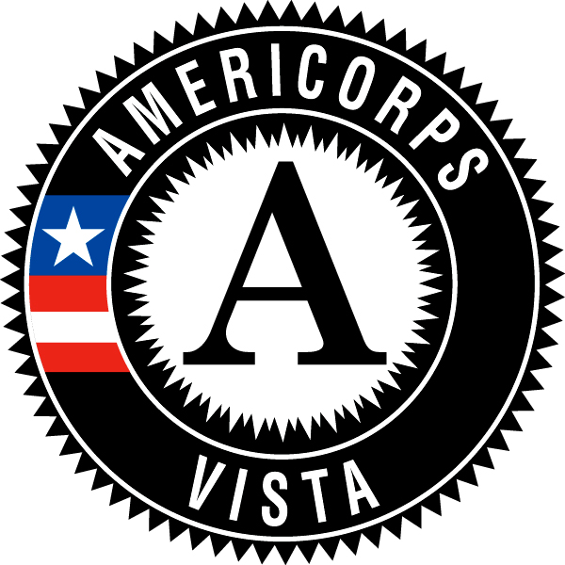
Campus Compact of Oregon VISTA
18-19 Full Program Calendar
*Weekend, can complete business day before or after
TIME SHEETS are due on the 15th and final (30th/31st) days of every month

Due or Activity Date | Report/Activity | Period Covered (if applicable)
August 27-30, 2018 | Pre-Service Orientation (PSO) | Members participate in Pre-Service Orientation organized by CNCS
August 31, 2018 | Member Start Date | First day on placement site
September 6, 2018 | VISTA and Supervisor 1:1 | Members and Supervisors work together to complete VISTA and Supervisor 1:1 form, submit to VISTA Leader
September TBD | Volunteer Management Training at Portland State University | Optional Volunteer Management Training for AmeriCorps Members tied to the Kick Off Event
September 17-19, 2018 | In-Service Training at Camp MaGruder | Members attend required training hosted by Campus Compact in Rockaway Beach, OR
September 25, 2018 | AmeriCorps Kickoff at Portland State University | Members highly encouraged to attend AmeriCorps Kickoff, a statewide AmeriCorps event with skill-building workshops included
October 2018 | Fall Check-ins | VISTA Leaders conduct required and structured phone check-ins with Members
October 5, 2018 | Member Development Plan due to Campus Compact | Members and Supervisors work together to outline a development plan for the service year, submit to VISTA Leader
October 27, 2018 | Make A Difference Day, National Day of Service | Members plan or participate in a service event, submit online survey report within two weeks
November 2, 2018 | Holiday Closure Plans and Teleservice checklists due to Campus Compact | Members and Supervisors work together to outline a plan for holiday leave time as well as complete teleservice checklists
December 5-7, 2018 | In-Service Training  Aldersgate Retreat Center | Members attend 2nd required training hosted by Campus Compact in Turner, OR
December 28, 2018 | Progress Report #1 Due | Members complete 1st required report online (time period: August 30 to December 15)
January 21, 2019 | MLK Day, National Day of Service | Members plan or participate in a service event, submit online survey report within two weeks
February 1, 2019 | Mid-Term Member Performance Evaluation | Members and Supervisors work together to complete mid-term evaluation, submit to VISTA Leader
February to March 2019 | Site Visits  TBD February & March | Campus Compact will conduct site visit with host sites
March 22, 2019 | Progress Report #2 Due | Members complete 2nd required report online (time period: December 15 – March 15)
May TBD | In-Service Training | Members come together for final required training hosted by Campus Compact in Portland, OR
June 7, 2019 | Progress Report #3 Due | Members complete 3rd required report online (time period: March 15 – June 1)
August 1, 2019 | Future Plans Due | Members must log on to their My.AmeriCorps portals and complete the Future Plans paperwork
August 1, 2019 | End of Term Member Performance Evaluation | Members and Supervisors work together to complete final evaluation, submit to VISTA Leader
August 2019 | Graduation  Location/Dates TBD | All VISTAs attend required Graduation
August 30, 2019  Last Day of Service | Progress Report #4/Sustainability Documents Due | Members complete final required report online (time period: June 1 – August 30)

